Summative assessment – Answers
A child-friendly version of the answer sheet which can be shared with pupils, or which you could use to provide verbal feedback, can be found at the bottom of the document.

Variables in games

Q1. Which of these are important features of a variable? Tick all that apply.

- Can be set
- Is a score
- Can be changed
- Has a clear name

The three correct features of a variable are that it can be set, it can be changed, and it should be named. A score is an example of what a variable might be used for, but there are also many other places in a program where they could be used.

Q2. Which data types can a variable hold?

- Numbers only
- Letters only
- Numbers or letters
- Pictures

The correct answer is C. Learners who choose answer A are likely to have the misconception that a value is always numeric. Learners who choose answer B may have the misconception that information is presented in the form of letters or words. Learners who choose answer D have not understood that a variable always holds a value.

Q3. How many values can a variable hold at any one time?

- None
- One
- Two
- Three

The correct answer is B. Learners who choose answer A have not understood that variables hold a value at all times. Learners who choose answer C or D have not understood that the value of a variable is replaced when it is updated. This means that a variable can only ever hold one value at any one time.

Q4. When a variable is changed, what happens to the value?

- It is replaced by a new value
- It is joined by the new value
- It is added to the new value

This question assesses learners’ understanding of the fact that when a value is updated, the previous value is replaced. Learners who choose answer B have not grasped that a variable can only hold one value at a time. Learners who choose answer C may have confused changing a variable by a positive integer (for example, 1) with replacing a value. The correct answer is A.

Q5. In a bat and ball game, which of these parts of the game would be stored using a variable? Tick all that apply.

- Points scored
- Movement of the sprite
- Lives lost
- Time left
- Appearance of the Stage

This question assesses learners’ understanding of aspects of a program that can be set and changed with variables. ‘Points scored’, ‘lives lost’, and ‘time left’ are all variables that learners have explored during this unit. The movement of a sprite is achieved using a simple code sequence and does not involve a variable. The appearance of the Stage is a design choice, which is not linked to any of the programming constructs.

Q6. Imagine that you are storing the score of a football match using a computer program to display to the crowd during the game. Which name would be the best choice for the variable that holds the score of the home team?

- Home score
- Home_score
- Football_match_home_team_score
- Score

Learners who choose answer A have not recalled that the name of a variable should not include a space. Learners who choose answer C have chosen the most detailed answer, but this would be too long to be practical in a project. Answer D does not differentiate between the home team’s score and the away team’s score. The best answer is B, which is brief, does not include any spaces, and contains enough information for the variable to be identified.

Q7. Where is the value of a variable usually set?

- At the beginning of a program
- Throughout the running of a program
- At the end of a program
- When triggered by an event

Learners who choose answer B or C have not understood that the value of a variable is set once, at the beginning of a program. The correct answer is A.

Q8. Which of the following code snippets would create a timer that counts down from 60 seconds to 0?

A.  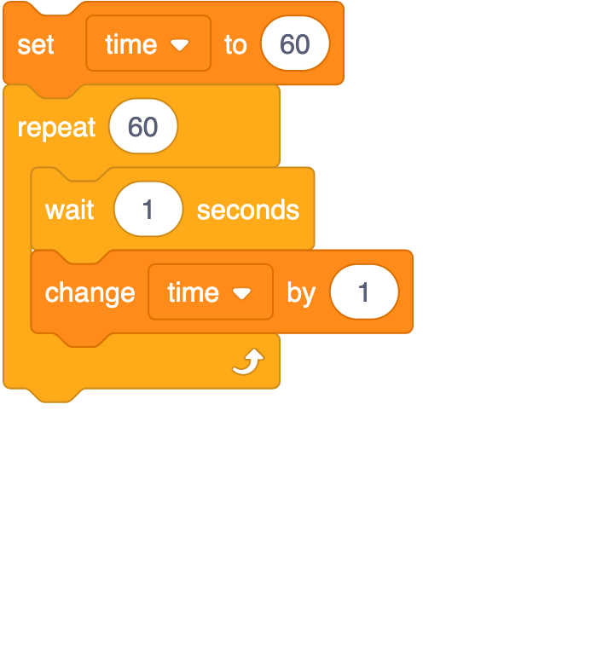 | B.  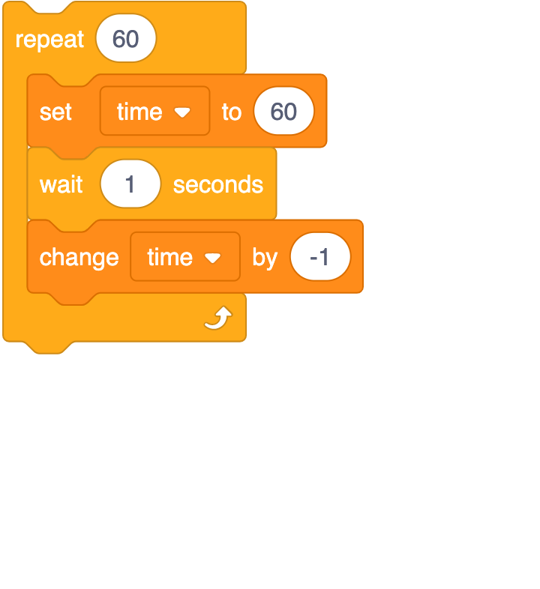
C.  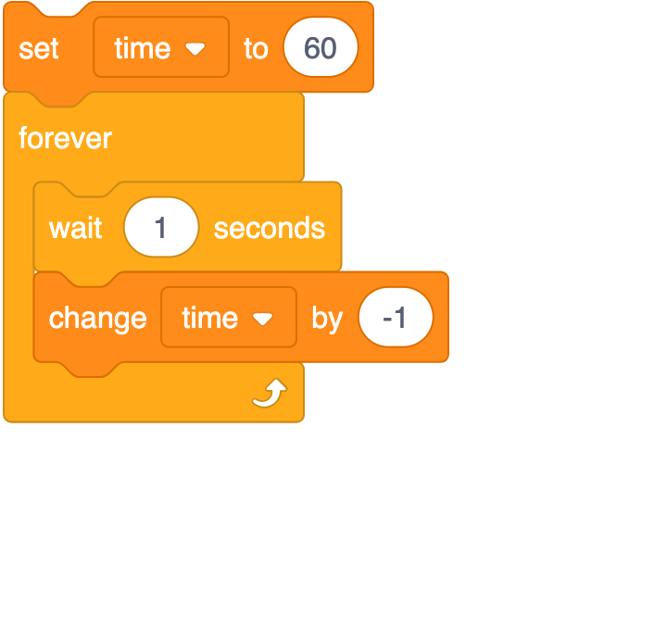 | D.  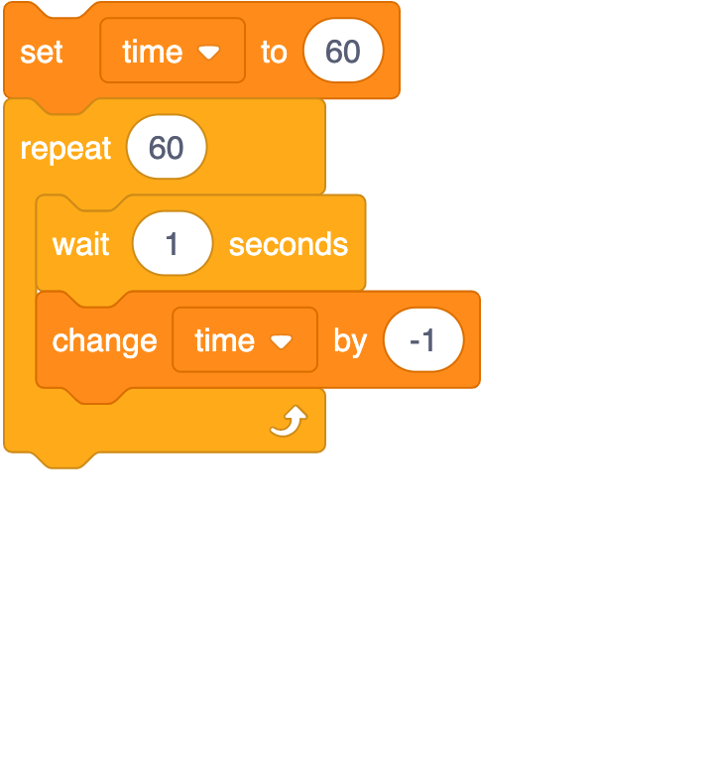

This is a code reading challenge. The correct answer is D — this will set the timer to 60, and then count down in intervals of one second 60 times. Each of the incorrect answers has one element of the code that would cause a different outcome. Answer A would set the timer to 60, but the timer would count onwards 60 times, to 120. Answer B would appear to stay at 60, although in reality, the program is looping a change by -1 block and then resetting to 60 every second for 60 seconds. Answer C would set the timer to 60, and count down in intervals of one second, but it would then carry on into negative numbers, as the repeat is a forever loop.

Q9. The code snippet below controls the movement of a ball in a game in the style of table tennis. The Stage is also shown next to the code.

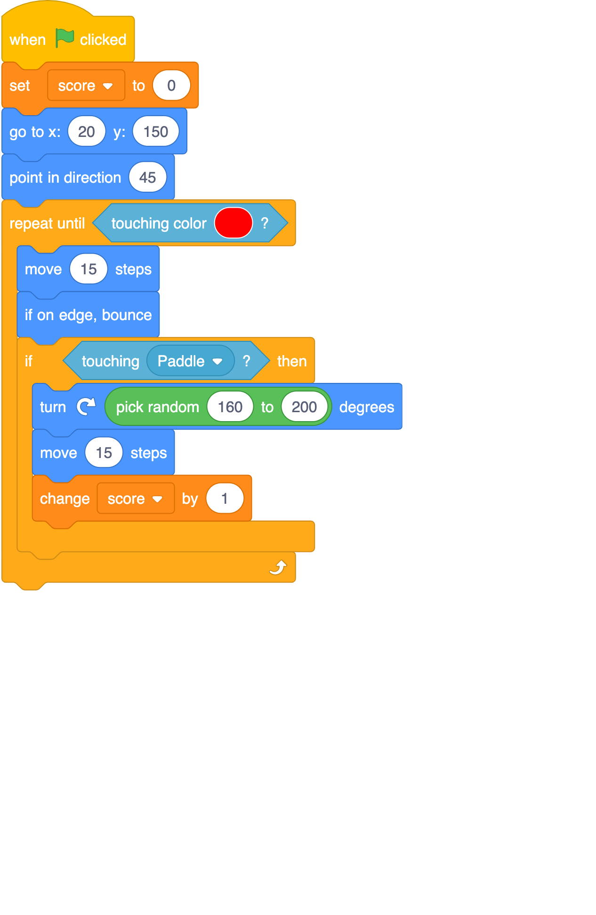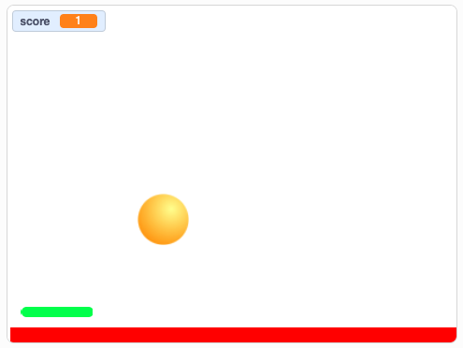

When will the score change?

- When the ball moves
- When the ball touches the paddle
- When the green flag is clicked
- When the ball hits the edge

This assesses how well learners can decompose a more complex code snippet. Learners who choose answer A have misread the move block within the if, then statement; this move block ensures that the ball does not stick to the paddle when it hits it. Learners who choose answer C have confused the set score block with change score. Learners who choose answer D demonstrate that they are unable to recognise variables within code. The correct answer is B, as it is within the if touching paddle then statement.

Q10. What describes the order in which commands are run during a program?

- The algorithm
- The code
- The program flow
- The task

This is the definition of ‘program flow’, which is defined in Lesson 4. Learners who choose answer A have confused the flow of a program with the ‘algorithm’ level of design. Algorithms are clear and unambiguous sets of instructions; they do not define the flow of a program. Answer B refers to the code in a program only, not the flow of the program when it is running. Answer D refers to the ‘task’ level of design; the program flow should enable the task to be met, but the task does not define it.

Summative assessment – Answers & Feedback

- The three correct features of a variables are that it can be set, it can be changed, and it should be named.
A score is an example of what a variable might be used for but it is not a feature of a variable.

- The correct answer is C. Variables can hold data in the forms of numbers of letters.

- The correct answer is B. A variable can only ever hold one value at any one time.

- The correct answer is A. When a variable is changed, the value is replaced by a new value. This is because a variable can only hold one value at any time.

- The following parts of the game could be stored using a variable: points scores, lives lost, and time left.
Movement of the sprite is achieved using a simple code sequence and does not involve a variable. Appearance of the stage is a design choice, which does not involve the use of a variable.

- The correct answer is B. The best choice would be Home_score as it is brief but contains enough information for the variable to be identified.
A is incorrect as this name includes a space. Variables should not include a space.
C is incorrect as the heading is too long and would not be practical to use in a project.
D is incorrect as the heading is too vague. Using ‘Score’ does not differentiate between the home team’s score and the away team’s score.

- The correct answer is A. The value of a variables is usually set at the beginning of a program, as part of the program setup.

- The correct answer is D. This code will set the timer to 60, and then count down in intervals of one second 60 times.
The code in A would set the timer to 60, but the timer would count onwards 60 times to 120, as the change time value is 1.
The code in B would count down from 60 to 59 but would then go back to 60.
The code in C would count down in intervals of one second but would not stop and carry on into negative numbers, as the repeat is a forever loop.

- The correct answer is B. The ‘change score by 1’ variable block is under the ‘if touching paddle’ statement so the score will change when the ball touches the paddle.

- The correct answer is C. The program flow is the order in which commands are run during a program.
Algorithms are clear sets of instructions; they do not define the flow of a program.
The code refers to the blocks used to create a program only, not the flow of the program when it is running.
The task is what the program should achieve. The program flow should enable the task to be met.

This resource was created by Raspberry Pi Foundation and updated by STEM Learning for the National Centre for Computing Education.

The contents of this resource are available for use under the Open Government License (OGL v3) meaning you can copy, adapt, distribute and publish the information. You must acknowledge the source of the Information in your product or application, by attributing Raspberry Pi Foundation and STEM Learning as stated here, and are asked to provide a link to the OGL v3.

The original version can be made available on request via info@teachcomputing.org.

Resources are updated regularly — the latest version is available at: ncce.io/tcc.

